Homepage Redesign Analysis: Global Trend

# Before vs. After Comparison

# Visuals Used in Redesign

*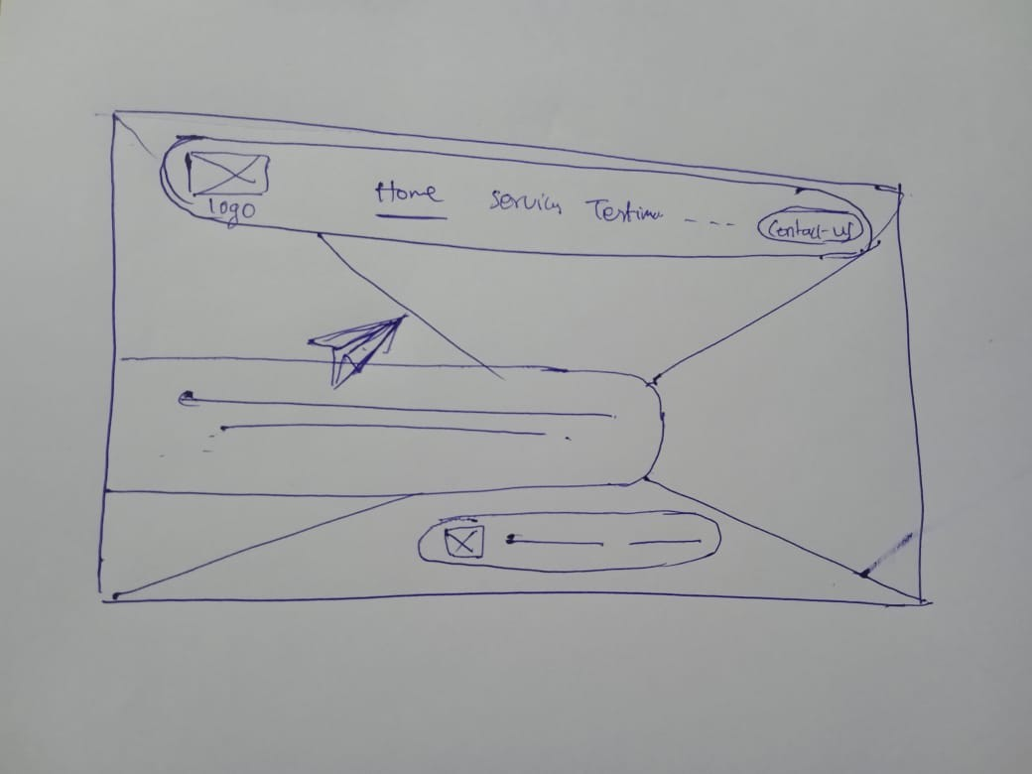Wireframe*

*Redesigned home page*

*After*

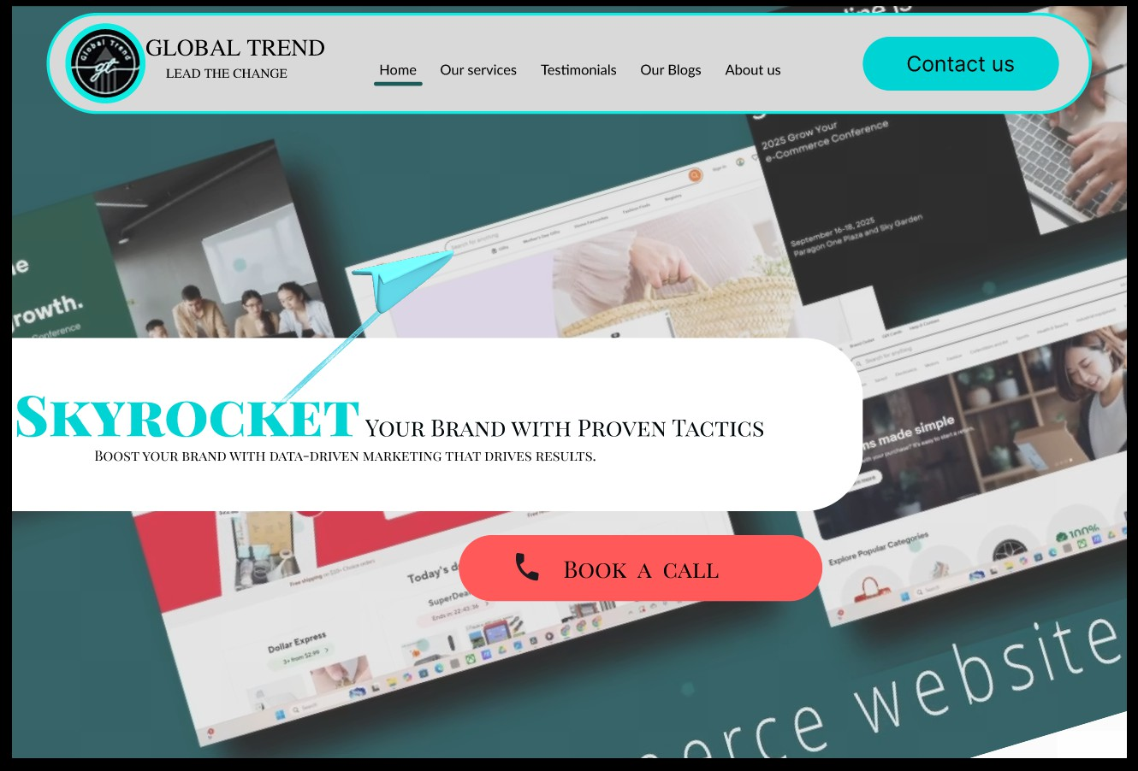

*Before*



# 1.What did you notice about the original website that inspired your redesign?

I found the original website to be quite boring and dark, with a black background that made it hard to engage with. The UI felt poorly designed, lacking clear structure and interactivity, which is essential to attract and retain visitors.

# 2.What changes did you make to the navigation bar and why?

I redesigned the navigation bar by curving its ends and adding a stroke around it for better visibility. I also reduced its length to improve readability and free up more space for showcasing work in the background. This helps users focus and find navigation easily while maintaining a clean layout.

3.How did you improve the call-to-action buttons?

I made the "Contact Us" and "Book a Call" buttons more visible and instantly noticeable by using bright colors that contrast well with the background. This helps grab user attention immediately and encourages interaction, which is key for lead generation.

# 4.How did you address the problem of unclear purpose on the original site?

The original website didn't clearly communicate what it was about. To fix this, I added examples of their work in the background to visually explain the services offered. I simplified the information and improved the UI to avoid overwhelming users with text, making it easier to understand the company's purpose at a glance.

# 5.What was your approach to typography and layout?

I aligned the heading and subheading to the left to save space and improve readability. I highlighted the main keyword "Skyrocket" in bold, large font to emphasize the company's key goal. The subheading uses a clean serif font for elegance, creating a professional but modern feel.

# 6.How did your design improve the overall user experience?

By adding interactive visual elements and clear CTA, I made the site more engaging and user-friendly. The curved nav-bar and strategic spacing reduce clutter. The background with work examples provides social proof without overwhelming text. All these changes make it easier for visitors to understand the company's services and take action.

# 7.What resources or inspiration did you use for your redesign?

I analyzed several modern agency and freelance websites to understand trends and best practices in UI/UX design. I focused on clarity, simplicity, and impact-ful visuals. I also used elements and video backgrounds provided on the original website for consistency and authenticity.